Profile

1. 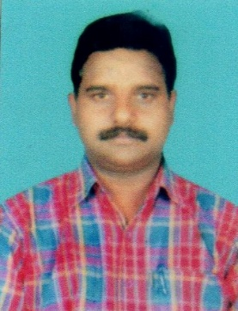Name : B.Venkateswara Rao
2. Designation : Lecturer in History
3. Date of Birth : 23-08-1971
4. Educational Qualifications : M.A., B.Ed.,
5. Teaching experience : 18 Years
6. Research Experience : NIL
7. Dissertation/Thesis Title : NIL
8. No. of Research publications : NIL
9. No. of Books Published : NIL
10. No. of Major/Minor Research Projects: NIL
11. Title of Minor Research Project: NIL
12. No. of International Conferences Attended : NIL
13. No. of National Conferences Attended : NIL
14. No. of Papers Presented at the Seminars/Conferences: NIL
15. Refresher Courses/Orientation Programs/Training Programs Attended: NIL
16. Vidwaan Score : NIL
17. Address : Near Bus Stand, Penugonda, W.G.Dt.
18. E-mail Id : charanmanohar7226@gmail.com
19. Contact no : 9618950075